RUSSIAN FIGURE SKATING CHAMPIONSHIP 2018
Saint Petersburg, Russia
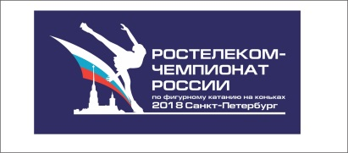 MEDIA ACCREDITATION
Аккредтационная ACCREDITATION deadline is 10 December 2017
APPLICATION FORM SEND TO vasiliy1221@mail.ru
Please, fill in the application form correctly!

ATTENTION: Only media representatives can get an accreditation for Russian Championship 2018. Accordingly, please, confirm, that the journalist represents a publication or a site, which are registered as mass media.
The application form should be filled in by each media representative. The application form is accepted only on publication letterhead, stamped and signed by the chief editor.
GENERAL INFORMATION
First Name, Last Name
Name of Media
phone number / Email
position (please, mark) | journalist | photographer | radio | TV | TV technician | other ______
Media | news agency / photo agency | Daily press | Weekly press | Monthly  press | TV company | Internet Media

Website ________________________________________________________________
Email ___________________________________________________________
Phone number
Chief Editor __________ Signature _________________________/ Full name /
Stamp here
Application forms without a stamp are not considered. All items of the application form must be filled in without any skip.

